# CS 255 System Design Document

By Lee Kitchen

## UML Diagrams

### UML Use Case Diagram

### UML Sequence Diagram

### UML Class Diagram

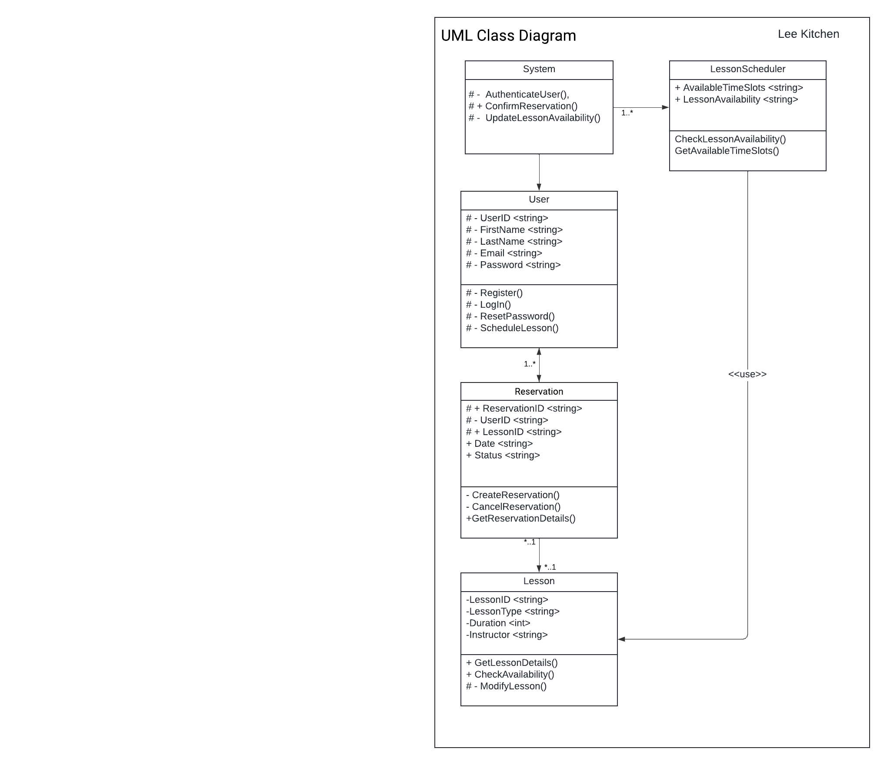

## Technical Requirements

1. **Hardware Requirements**:
   1. Server Infrastructure: Deploy a robust server infrastructure to handle the system's web-based operations and database management.
   2. Database Server: Set up a dedicated database server to efficiently manage and store user data, reservations, and system logs.
   3. Network Infrastructure: Ensure a stable and secure network infrastructure to facilitate seamless communication between clients and servers.
   4. Backup Systems: Implement regular backup systems to safeguard data integrity and provide recovery options in case of system failures.

1. **Software Requirements**:
   1. Web Application Framework: Utilize a suitable web application framework to facilitate the development and maintenance of the user interface and application logic.
   2. Database Management System (DBMS): Select a reliable DBMS to efficiently manage and organize the system's database, ensuring data integrity and security.
   3. Operating System: Choose an operating system that supports the web application framework and database management system.
   4. Browser Compatibility: Ensure compatibility with major web browsers, including Google Chrome, Mozilla Firefox, and Safari, to enhance accessibility for users.
2. **Tools**:
   1. Development Tools: Use integrated development environments (IDEs) and version control systems for collaborative and efficient software development.
   2. Security Tools: Employ security tools for encryption, access control, and regular security audits to protect user data and privacy.
   3. Database Design Tools: Utilize tools for designing and managing the database schema, ensuring optimal performance and scalability.
3. **Infrastructure**:
   1. Cloud-Based Environment: Host the system in a cloud-based environment for scalability, reliability, and efficient resource management.
   2. Load Balancing: Implement load balancing mechanisms to distribute incoming traffic evenly across multiple servers, optimizing performance.
   3. Scalability: Design the system architecture to be scalable, allowing it to handle an increasing number of users and transactions.
4. **Integration**:
   1. DMV Connectivity: Establish and maintain a secure connection with the DMV for real-time updates on standards, regulations, and testing requirements.
   2. External Services: Integrate external services for features such as security audits and vulnerability assessments to enhance overall system security.
5. **Security**:
   1. Data Encryption: Implement industry-standard encryption protocols to secure sensitive user data during transmission and storage.
   2. Role-Based Access Control: Establish a role-based access control system to manage user roles and permissions, ensuring data privacy and system security.
   3. Audit Trail: Develop an audit trail system to log and monitor significant activities, enhancing security and accountability.
6. **Performance**:
   1. Response Time: Optimize system performance to ensure a maximum response time of 2 seconds for user actions, providing a smooth and efficient user experience.
   2. Concurrent Users: Design the system to support a minimum of 500 concurrent users during peak times without significant degradation in performance.
7. **Adaptability**:
   1. Device Adaptability: Ensure the system's user interface adapts seamlessly to various devices, including desktops, laptops, tablets, and mobile phones.
   2. Customization: Allow for future customization of training packages and additional features without disrupting existing functionalities.

These technical requirements provide a foundation for the development and deployment of the DriverPass system, addressing hardware, software, tools, infrastructure, integration, security, performance, and adaptability aspects. ]